Movie Navigation Website Prototype

# Wireframes

1. Home Page

This will be the landing page of the application. On this page , we can display different genres, newly added, upcoming movies etc. This page also has search functionality.

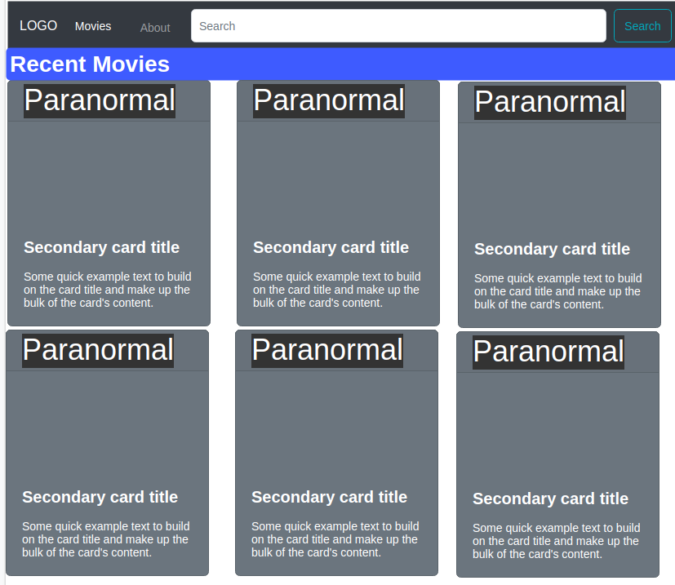

b.) search

This functionality is used to search the movie details. Once a user enters the search keyword and clicks on the search button the search results can be shown.

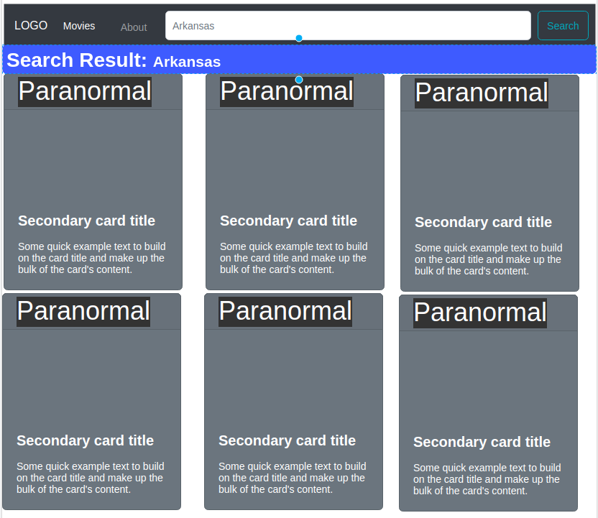

c.) Movie Details

This page is used to show the details of a movie.

